**Thomas Flynn**

**G00291875**

**Sprint 2 Week 2**

**15/11/15**

**Updates:**

This week I managed to play an mp3 file on my GUI. This was an integral goal I had to achieve.

The next goal was to be able to play the next song with a button click. This proved to be a little difficult. I overcame this problem by creating an array of JavaFX media Player objects for every song in the database. This might not be the most efficient way of doing things, but for the purpose of getting as much “functionality” working by the 10th December presentation I chose to do it this way.

**Research:**

In the logs you’ll be able to see the time dedicated to researching the JavaFX API. Learning this new API proved to be a bit of a stumbling block as opposed to using the Java Swing library which I’m much more familiar with. The reason for choosing this was so that I could talk about this API in future potential job interviews as this API is replacing Java Swing more and more every day.

**Tasks completed:**

Played mp3 file using javaFX API.

Skip song button working.

Researched SQLite for Android.

Server receives String from Client.

Setup Git Repositories for the Project.

**Project Board Start of week**

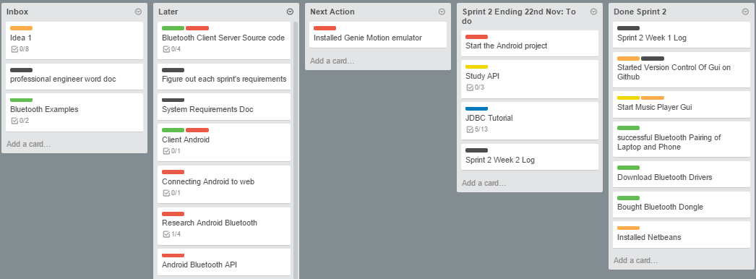

**Project Board End of week**

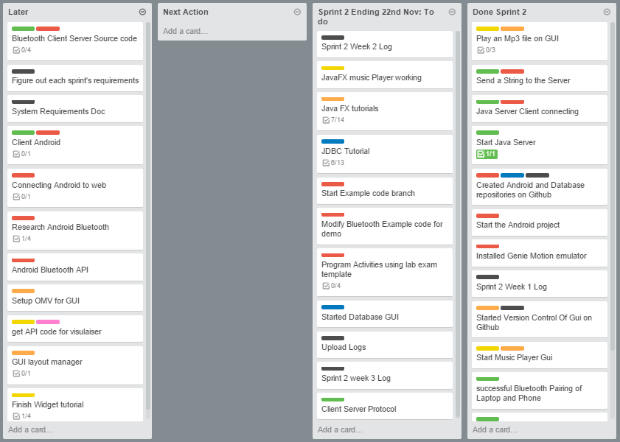

**Time Logs:**

**Weekly Bar chart:**

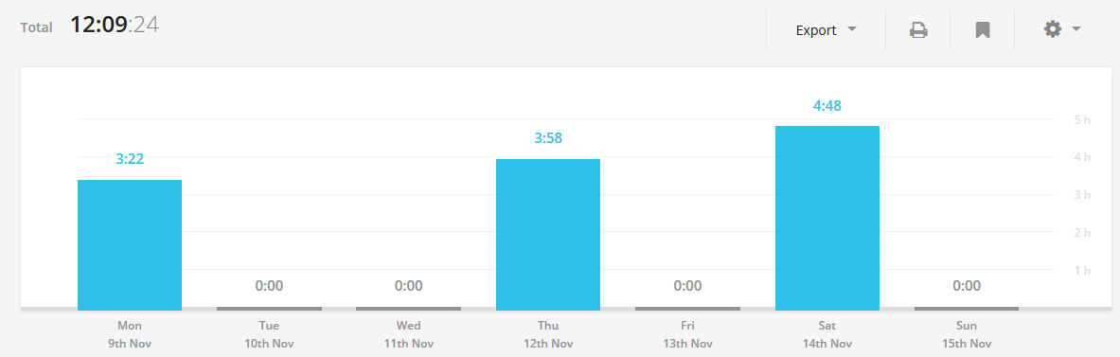

**Weekly Log:**

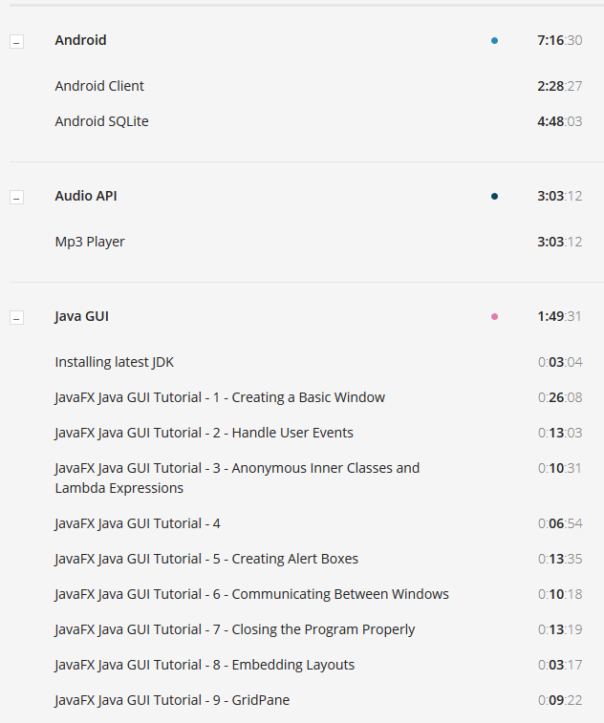

**Weekly pie Charts:**



